Jelly Beans Kids Club Ltd  C/0 Brookland Infant School  Hill Top  London NW11 6EJ | 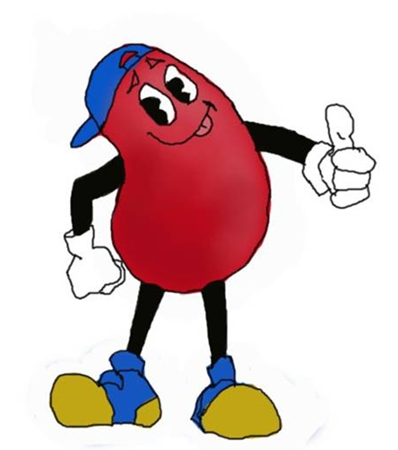 | Jelly Beans Kids Club Ltd  6 Fallows Close  London N2 8LG

JELLY BEANS KIDS CLUB LTD WHERE ‘EVERY CHILD MATTERS’.

Dear Parents/Carers,

Our name is Jelly Beans Kids Club Ltd, and we are a private after school club, managed by Julia Fritz, who is fully qualified and has over twelve years experience in after school care. We believe in equal opportunities for all our members of staff and the children, who attend the provision. It is our mission, that every child who attends, is treated as an individual and our policies reflect this belief.

Jelly Beans Kids Club Ltd is registered with Ofsted and all the staff are experienced and DBS checked.

Jelly Beans Kids Club Ltd offers the following:
- A daily service Monday to Friday during term time from 3.15pm to 5.50pm.
- Our fees are: £6.00 per child to 4.30pm, £11.00 per child to 5.50pm (£9.00 each for siblings) and £7.00 when joining us after another club.
- There is a non-refundable registration fee of £5.00 and our registration forms must be completed, before your child/children attend.
- Bookings need to be made in advance; though we do offer an ad -hoc service, in the event of an emergency.
- You can book as far ahead as you like but we do require 24 hours notice of cancellation.
- We offer numerous activities to help develop and provide new skills for the children who attend. Activities include team games, arts & crafts, free play, board games and construction, a homework area and much more.

To contact Jelly Beans Kids Club Ltd
Call or text: 07799397959
Email: juliafritz123@gmail.com

Alternatively, you can collect a Parents Pack from the Infant School Office or from the Jelly Beans Kids Club team, who are available in the Infant dining hall area, each afternoon from 3pm.

Kind Regards
Julia Fritz
Managing Director

